Data Flow in a Web Application
A typical web application follows a client-server architecture.
When a user interacts with an application, the request is sent through the frontend interface to the backend server. The backend processes the request and communicates with the database to store or retrieve data.
The processed data is then used to generate insights, which are displayed on an analytics dashboard.
Flow:
User → Frontend → Backend → Database → Dashboard
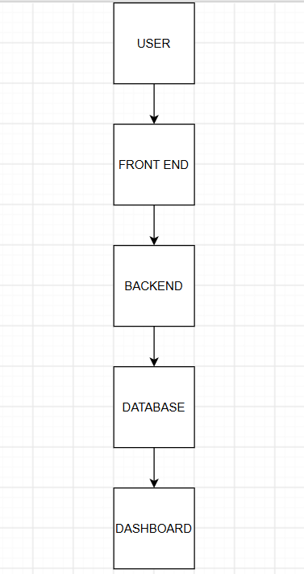
Data Flow Explanation
When a user interacts with a web application, the request is sent through the frontend interface to the backend server. The backend processes the request and interacts with the database to store or retrieve data. This data is then used to generate insights, which are displayed on an analytics dashboard for decision-making.

